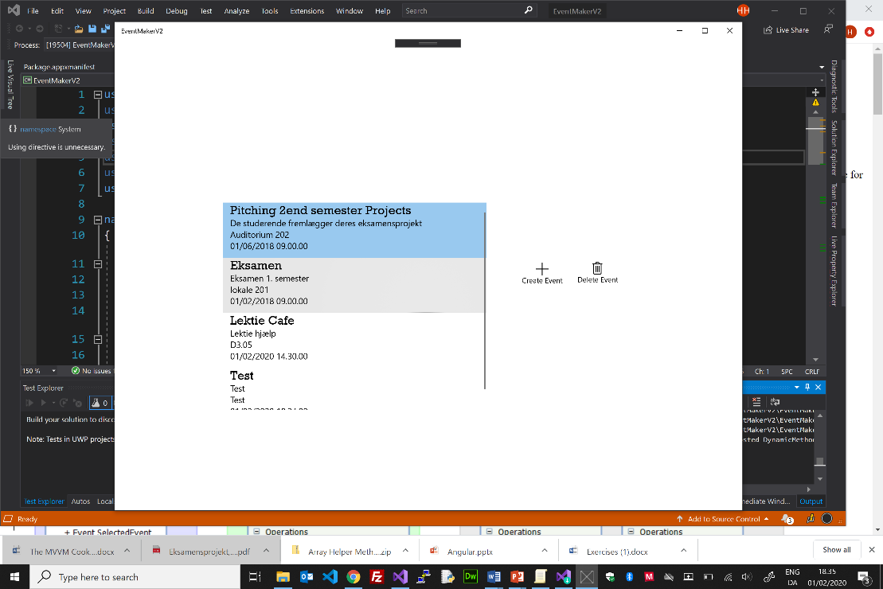

<**Page**

xmlns="http://schemas.microsoft.com/winfx/2006/xaml/presentation"

xmlns:x="http://schemas.microsoft.com/winfx/2006/xaml"

xmlns:local="using:EventMakerV2.View"

xmlns:ViewModel="using:EventMakerV2.ViewModel"

xmlns:d="http://schemas.microsoft.com/expression/blend/2008"

xmlns:mc="http://schemas.openxmlformats.org/markup-compatibility/2006"

xmlns:Interactivity="using:Microsoft.Xaml.Interactivity" xmlns:Core="using:Microsoft.Xaml.Interactions.Core"

x:Class="EventMakerV2.View.EventPage"

mc:Ignorable="d">

<**Page.Resources>**

<**DataTemplate** x:Key="**EventDataTemplate**">

<Grid>

<StackPanel HorizontalAlignment="Left" … >

<TextBlock Text="{Binding **Name**.. }" … />

<TextBlock Text="{Binding **Description**}" …./>

<TextBlock Text="{Binding **Place**}" …../>

<TextBlock Text="{Binding **DateTime**}" …./>

</StackPanel>

</Grid>

</DataTemplate>

</Page.Resources>

<**Page.DataContext**>

<ViewModel:EventViewModel/>

</Page.DataContext>

<**Grid**>

<**ListView** **ItemsSource**="{Binding EventCatalogSingleton.Events}" **ItemTemplate**="{StaticResource **EventDataTemplate**}">

<Interactivity:Interaction.Behaviors>

<Core:EventTriggerBehavior EventName="SelectionChanged">

<Core:InvokeCommandAction Command="{Binding SelectEventCommand}" CommandParameter="{Binding SelectedItem }"/>

</Core:EventTriggerBehavior>

</Interactivity:Interaction.Behaviors>

</ListView>

<**AppBarButton** Icon="Add" Label="Create Event" …. >

<Interactivity:Interaction.Behaviors>

<Core:EventTriggerBehavior EventName="Click">

<Core:**NavigateToPageAction** TargetPage="EventMakerV2.View.CreateEventPage"/>

</Core:EventTriggerBehavior>

</Interactivity:Interaction.Behaviors>

</AppBarButton>

<**AppBarButton** Icon="Delete" Label="Delete Event" ….. >

<Interactivity:Interaction.Behaviors>

<Core:EventTriggerBehavior EventName="Click">

<Core:**InvokeCommandAction** Command="{Binding **DeleteEventCommand**}"/>

</Core:EventTriggerBehavior>

</Interactivity:Interaction.Behaviors>

</AppBarButton>

</Grid>

</Page>

“Binding”

ItemSource

Datacontext

Observable Collection

**ListView**

**EventViewPage**

**EventViewModel**

EventHandler

async void **DeleteEvent**()  
{…..}

RelayCommand

ICommand

“Binding”  
Command

ICommand **DeleteEventCommand**

public ICommand **DeleteEventCommand**

{

get { return _deleteEventCommand ?? (_deleteEventCommand = new **RelayCommand**(EventHandler.**DeleteEvent**)); }

set { _deleteEventCommand = value; }

}

Int Id

string Name

string Description

string Place

DateTime DateTime

EventModel