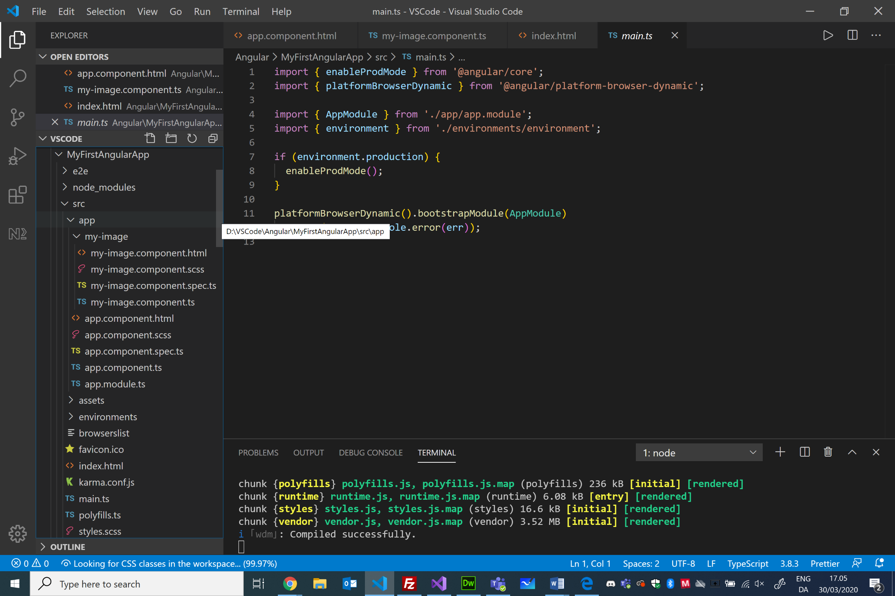

Template (view)

Component (Class)

Template (view)

Metadata

<!doctype html>

<html lang="en">

<head>

  <meta charset="utf-8">

  <title>MyFirstAngularApp</title>

  <base href="/">

  <meta name="viewport" content="width=device-width, initial-scale=1">

  <link rel="icon" type="image/x-icon" href="favicon.ico">

</head>

<body>

  <**app-root**></app-root>

</body>

</html>

C/Henrik Høltzer, Zealand March 30. 2020

MyFirstAngularApp

import { Component } from '@angular/core';

@Component({

  selector: **'app-root'**,

  templateUrl: './app.component.html',

  styleUrls: ['./app.component.scss']

})

export class AppComponent {

**title** = 'Henrik Høltzer';

}

<p>

  <img src="assets/SemiHires_HEHO.jpg">

</p>

import { Component, OnInit } from '@angular/core';

@Component({

  selector: **'app-my-image'**,

  templateUrl: './my-image.component.html',

  styleUrls: ['./my-image.component.scss']

})

export class MyImageComponent implements OnInit {

  constructor() { }

  ngOnInit() {

  }

}

<div style="text-align:center">

  <h1>

    Hello {{ **title**}}!

  </h1>

  <**app-my-image**>Test ...</app-my-image>

</div>

import { BrowserModule } from '@angular/platform-browser';

import { NgModule } from '@angular/core';

import { AppComponent } from './app.component';

import { MyImageComponent } from './my-image/my-image.component';

@NgModule({

  declarations: [

    AppComponent,

    MyImageComponent

  ],

  imports: [

    BrowserModule

  ],

  providers: [],

  bootstrap: [AppComponent]

})

export class AppModule { }

Component (Class)

Metadata

