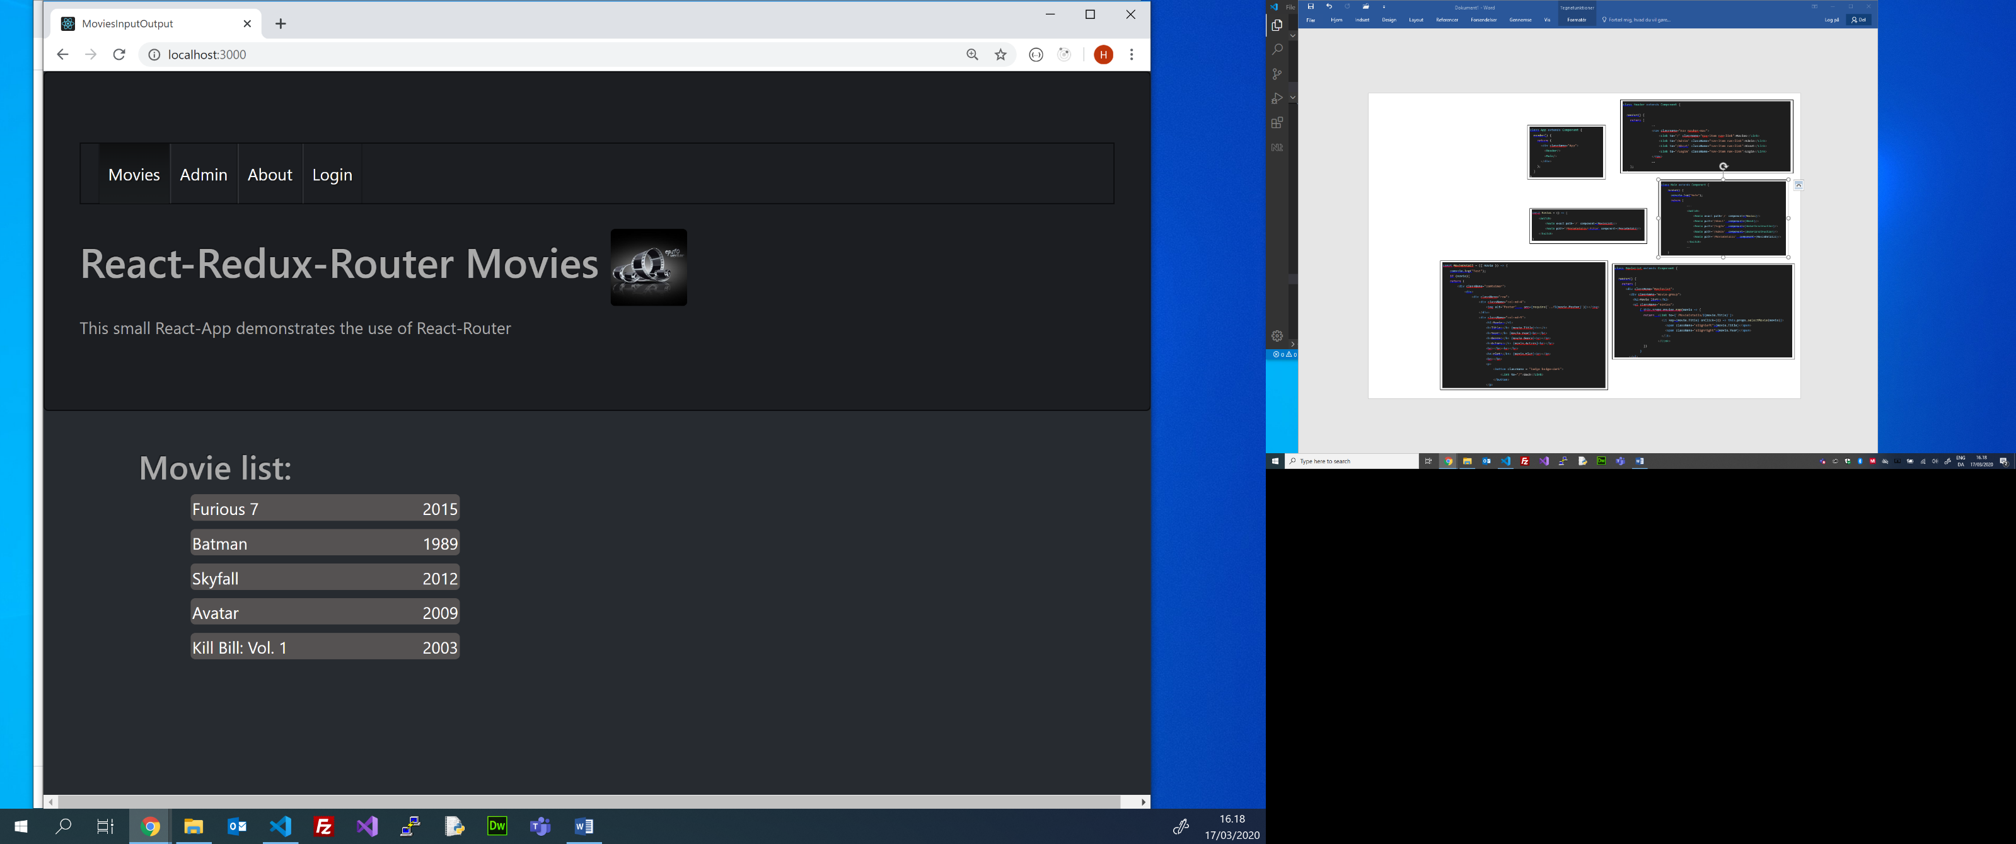

React-Redux-Router Overview (Movie App)

ReactDOM.render(

    <Provider store={createStore(reducers)}>

        <**BrowserRouter**>

**<App** />

        </**BrowserRouter**>

    </Provider>,

     document.getElementById('root')

);

class **Header** extends Component {

  render() {

    return (

….

                <nav className="nav navbar-nav">

                    <Link to='/' className="nav-item nav-link">Movies</Link>

                    <Link to='/Admin' className="nav-item nav-link">Admin</Link>

                    <Link to='/About' className="nav-item nav-link">About</Link>

                    <Link to='/Login' className="nav-item nav-link">Login</Link>

                </nav>

             ….

    );

  }

}

**const MovieDetai**l = ({ movie }) => {

    console.log("Test");

    if (movie){

    return (

        <div className="container">

            <div>

                <div className="row">

                    <div className="col-md-4">

                        <img alt="Poster" .. src={require(`../${movie.Poster}`)}></img>

                    </div>

                    <div className="col-md-5">

                        <h1>Movie:</h1>

                        <b>Title:</b> {movie.Title}<b></b>

                        <b>Year:</b> {movie.Year}<br></br>

                        <b>Genre:</b> {movie.Genre}<br></br>

                        <b>Actors:</b> {movie.Actors}<br></br>

                        <br></br><br></br>

                        <h4>Plot:</h4> {movie.Plot}<br></br>

                        <br></br>

                        <p>

                            <button className = "badge badge-dark">

                                <Link to="/">Back</Link>

                            </button>

                        </p>  
 ……  
    );

    }

    return null;

  }

class**MovieList** extends Component {

  render() {

    return (

      <div className="MovieList">

        <div className="movie-group">

          <h2>Movie list:</h2>

          <ul className="movies">

              { this.props.movies.map(movie => {

                return  <Link to={`/MovieDetails/${movie.Title}`}>

                          <li key={movie.Title} onClick={() => this.props.selectMovie(movie)}>

                            <span className="alignleft">{movie.Title}</span>

                            <span className="alignright">{movie.Year}</span>

                          </li>

                        </Link>

                })

              }

        </ul>

      </div>

      </div>

    );

  }

}

class**Main** extends Component {

    render() {

      console.log("Main");

      return (  
 …..

                <Switch>

                    <Route exact path='/' component={**Movies**}/>

                    <Route path='/About'  component=**{About**}/>

                    <Route path='/Login'  component={UnderConstruction}/>

                    <Route path='/Admin'  component={UnderConstruction}/>

                    <Route path='/MovieDetails'  component={**MovieDetail**}/>

                </Switch>

….

    }

  }

class **App** extends Component {

  render() {

    return (

      <div className="App">

        <**Header**/>

        <**Main**/>

      </div>

    );

  }

}

const **Movies** = () => (

    <Switch>

        <Route exact path='/' component=**{MovieList**}/>

        <Route path='/MovieDetails/:Title' component={**MovieDetail**}/>

    </Switch>

)

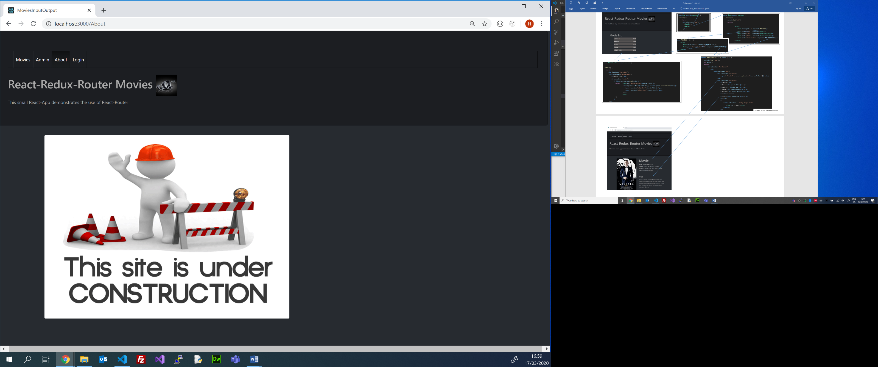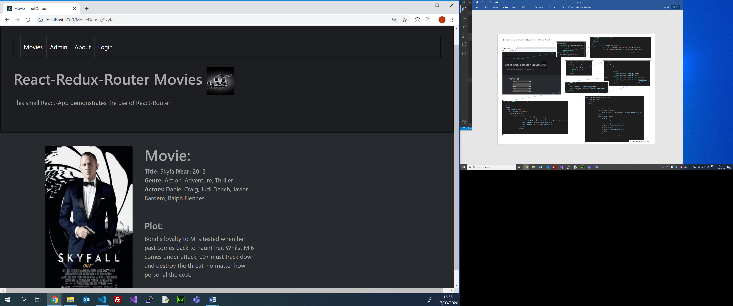

C/Henrik Høltzer Zealand 17.3 2020

class **About** extends React.Component {

    render () {

        return <img alt="Under Construction"  src={require('../assets/Image/underconstruction.gif')}></img>

    }

};