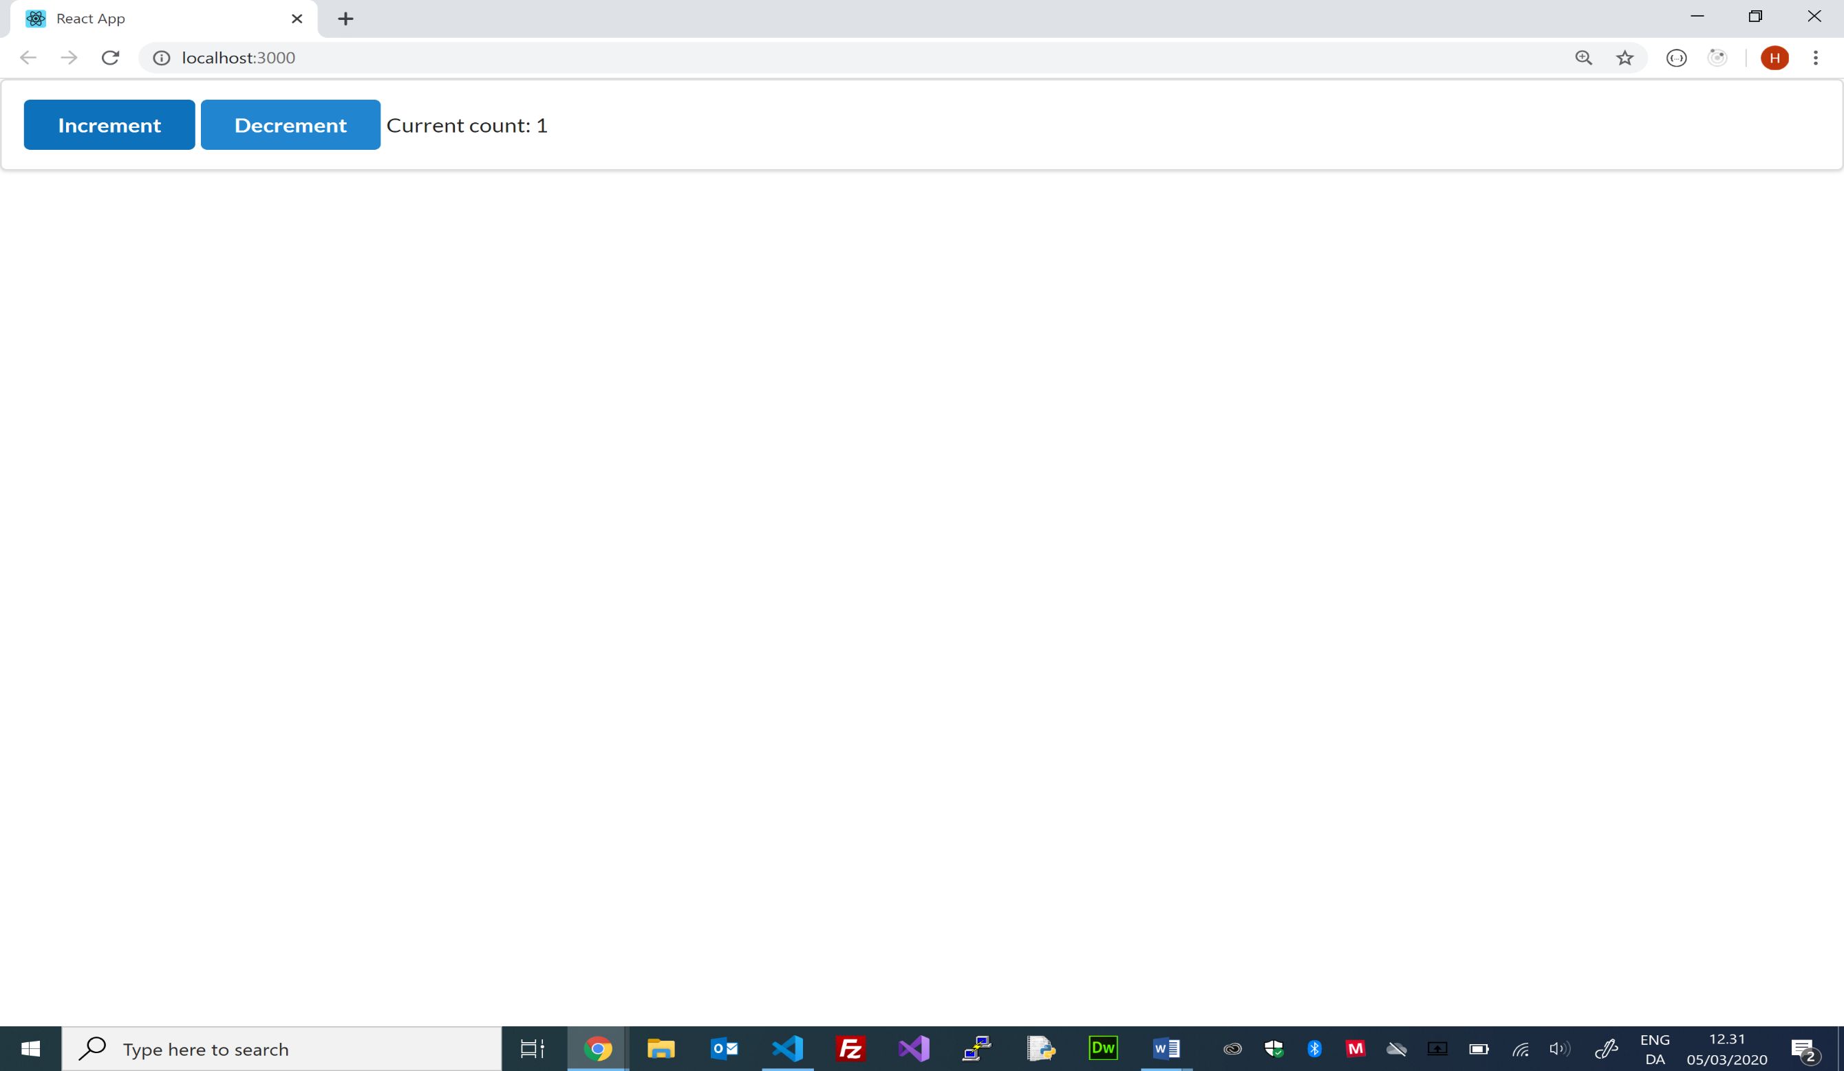

The connect-function create a container-component that contains the Counter component. The Connect-container pass ‘state’ and ‘action creator functions’ as props to the Count component.

onClick event invokes the ‘Action-Creator’ function and the container calls the dispatch-function of the Store with the returned Action-object as argument). The container component is a subscriber to the Store and “re-render” the Count-component when the state (Count) is updated

The Count App have only one Reducer: countReducer and the Store only one state object: Count. The state Count is created the first time the countReducer is called with ‘undefined’ as statevalue. The state count is assigned the defaultvalue: 0

export const **countReducer** = (count=0, action) => {

    if (action.type === 'INCREMENT') { return count + 1; }

    if (action.type === 'DECREMENT') { return count - 1; }

    return count;

};

C/Henrik Høltzer Zealand 5.3 2020

const **Counter** = (props) => {

    return (

        <div>

            <button className="ui button primary" **onClick={props.increment}>**

                Increment

            </button>

            <button className="ui button primary" **onClick={props.decrement}>**

                Decrement

            </button>

            Current count: <span>{**props.count**}</span>

        </div>

    );

};

const **mapStateToProps** = (state) => { return { **count: state.count** }; };

const **mapDispatchToProps** = **{increment, decrement};**

export default **connect(mapStateToProps, mapDispatchToProps Counter)**;

React-Redux Overview (Count App)

1

ReactDOM.render(

    <Provider store={createStore(countReducer)}>

        <App />

    </Provider>,

     document.getElementById('root')

);

export const increment = () => ({ type: 'INCREMENT'});

export const decrement = () => ({ type: 'DECREMENT'});

1

Count

NewState

0

0

{ type : ‘INCREMENT’ }

countReducer (state, action)

dispatch(action)

decrement

increment

Props.count

Props.increment

Props.decrement

connect(mapStateToProps, mapDispatchToProps)

Props

Counter

Connect

App

Provider

{ type : ‘DECREMENT’ }

{ type : ‘INCREMENT’ }

Action Creator

Action

Count

State

Store

Dispatcher

Reducers