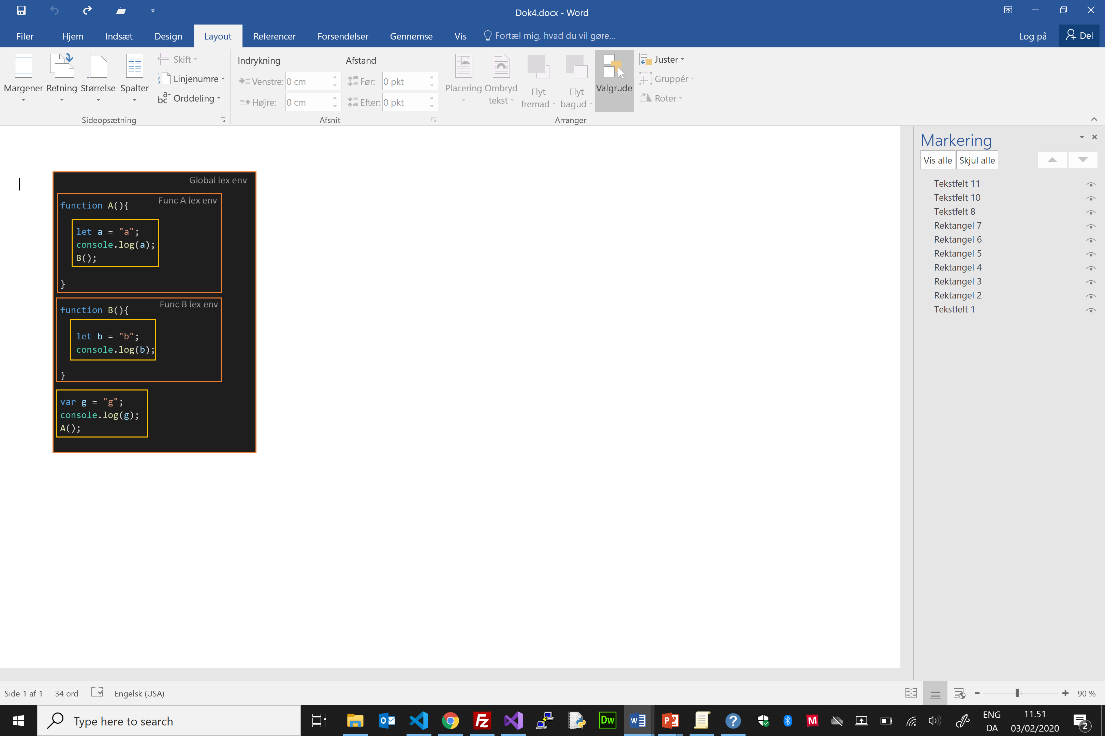

Null

**JS Execution Environment** **- 2020** Copyright: Henrik Høltzer / Zealand

**Lexical environment  
Execution context**

Local B

Local A

This

This

Outer   
Environment

Outer   
Environment

a

console.log(a);

B();

b

console.log(a);

B();

Window

a = "a"  
console.log(a);   
B();

console.log(a);

B();

Outer   
Environment

This

Global   
Object

A()  
B()  
g

console.log(a);

B();

b = "b";

console.log(b);

Code

Code

Code

g = "g";

console.log(g);  
A();

Func B ex con

Func A ex con

Global ex con