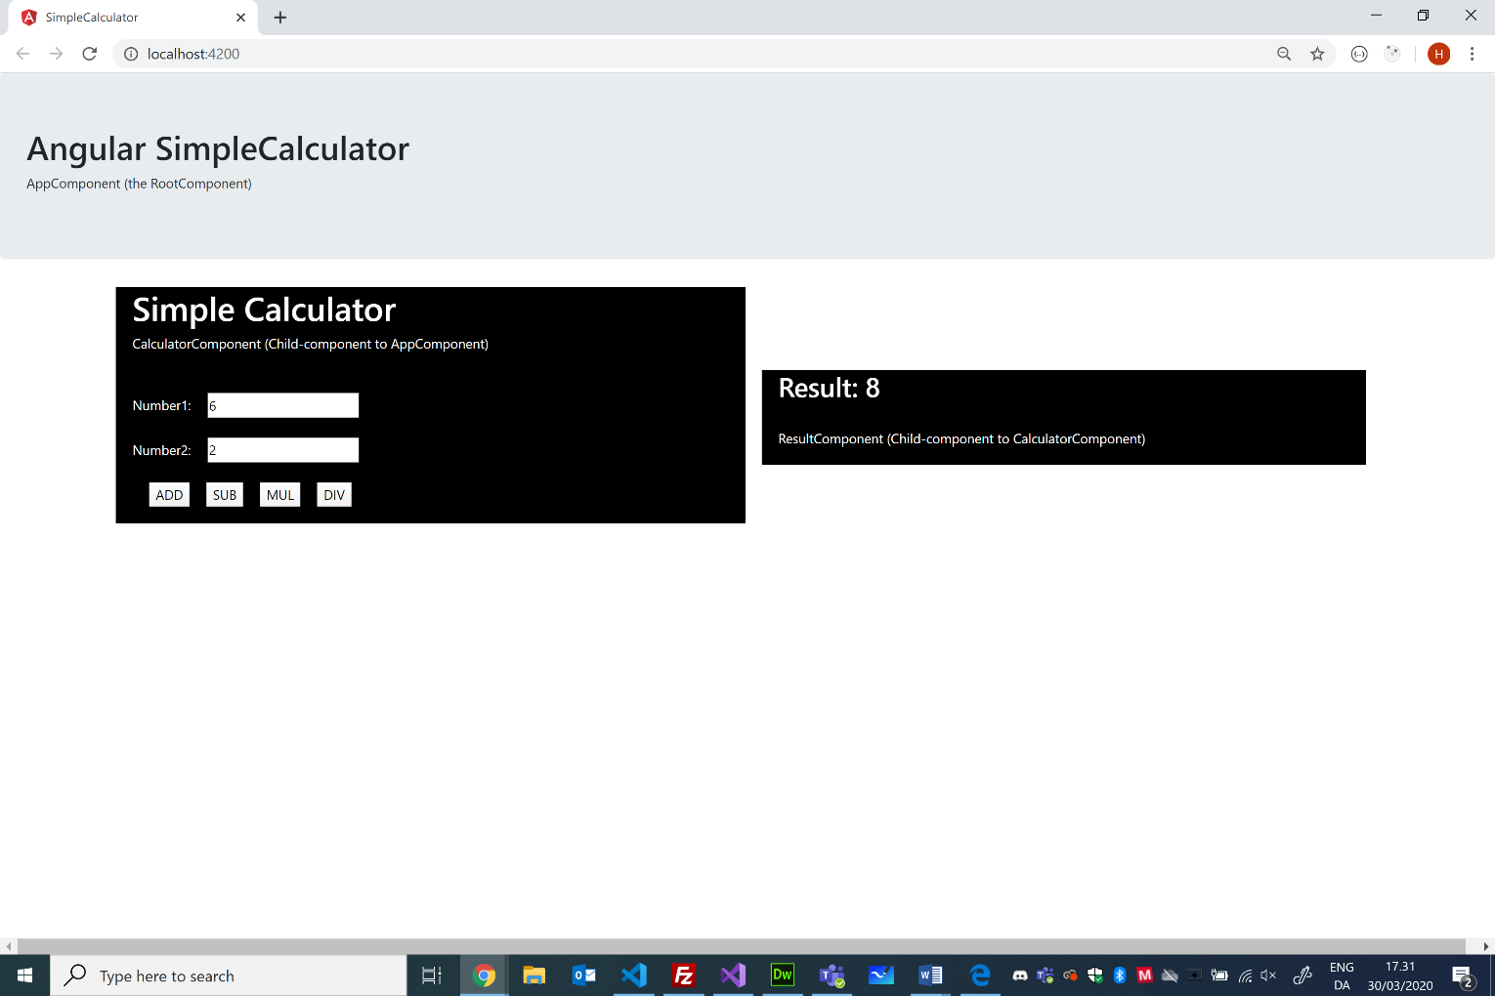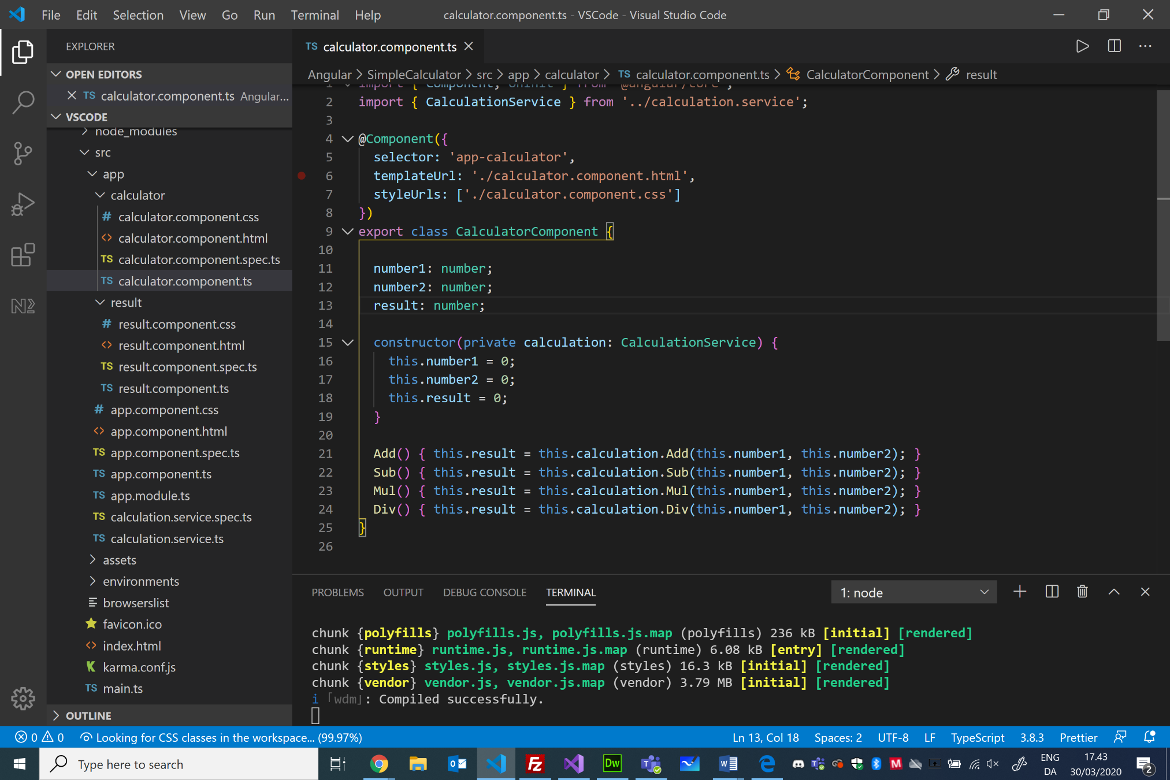

9

8

7

6

5

4

2

1

3

<div class="jumbotron">

  <h1>Angular SimpleCalculator</h1>

  <p>AppComponent (the RootComponent)</p>

</div>

<app-calculator>Loading ....</app-calculator>

import { Component } from '@angular/core';

@Component({

  selector: 'app-root',

  templateUrl: './app.component.html',

  styleUrls: ['./app.component.css']

})

export class **AppComponent** {

  title = 'SimpleCalculator';

}

Notice the registration in the App module of the provided service: CalculationService

Notice the @Injectable annotation

@NgModule({

  declarations: [

    AppComponent,

    CalculatorComponent,

    ResultComponent

  ],

  imports: [

    BrowserModule,

    FormsModule

  ],

  providers: [CalculationService],

  bootstrap: [AppComponent]

})

export class AppModule { }

Event-binding

<div class="row">

  <div class="col-1"></div>

  <div class="col-5" id="calc">

    <h1>Simple Calculator</h1>CalculatorComponent (Child-component to AppComponent)<br><br><br>

    Number1:<input type=number **[(ngModel)]="number1"**id="x"><br><br>

    Number2:<input type=number **[(ngModel)]="number2**" id="y"><br><br>

    <button **(click)="Add()">**ADD</button>

    <button (click)="Sub()">**SUB</button>**

**<button**(click)="Mul()">MUL</button>

    <button **(click)="Div()">**DIV</button>

  </div>

  <div class="col-5">

    <app-result **[result]="result">**Loading....</app-result>

  </div>

  <div class="col-1"></div>

</div>

C/Henrik Høltzer, Zealand March 30. 2020

SimpleCalculator

Dependency injection of the CalculationService

“Banana in a box” – 2-way binding

Notice the @Input annotation

Passing a property (result) from parent (Calculator-component) to child (Result-component)

export class **ResultComponent**{

**@Input('result')**

  public **result**: number;

  constructor() { }

}

<div id="res">

  <h2>Result**: {{result}}</**h2><br>

  ResultComponent (Child-component to CalculatorComponent)

</div>

export class **CalculatorComponent** {

  number1: number;

  number2: number;

  result: number;

  constructor(private calculation: **CalculationService**) {

    this.number1 = 0;

    this.number2 = 0;

    this.result = 0;

  }

  Add() { this.result = this.calculation.Add(this.number1, this.number2); }

  Sub() { this.result = this.calculation.Sub(this.number1, this.number2); }

  Mul() { this.result = this.calculation.Mul(this.number1, this.number2); }

  Div() { this.result = this.calculation.Div(this.number1, this.number2); }

}

import { **Injectable** } from '@angular/core';

**@Injectable**({

  providedIn: 'root'

})

export class **CalculationService** {

  constructor() { }

  Add(number1: number, number2: number): number { return number1 + number2; }

  Sub(number1: number, number2: number): number { return number1 - number2; }

  Mul(number1: number, number2: number): number { return number1 * number2; }

  Div(number1: number, number2: number): number { return number1 / number2; }

}

